The diffraction of light through a very thin slit can be explained by classical mechanics, specifically by examining the wave properties of light. The same analysis yielded an (albeit weaker) derivation of the Heisenberg Uncertainty Principle.

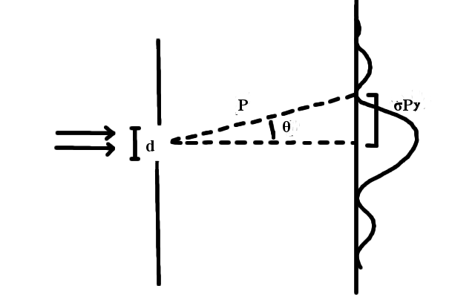

**Fig X. Cross section of single slit diffraction.** Parallel rays of light enter from the left of the figure, and contrary to classical intuition, diffuses, and creates a pattern along the right side.

The location of the first dark fringe is well known, and given by [X1]. Elementary trigonometry yielded [X2].

$d⋅sin(θ)=λ$ [X1]

Where: d = width of slit

$θ$ = angle of first dark fringe

$p⋅sin(θ)=σ_{Py}$ [X2]

Where:

Py = standard deviation of y component of momentum

Specific information is known about a photon as it passes through the single slit, namely, it’s position. This is expressed in [X3].

$σ_{y}=d$ [X3]

Where: $σ_{y}$ = position of photon

These three equations are combined with [A], and yielded the following.

$σ_{y}⋅σ_{Py}=h$ [X4]

This is a crude representation of Heisenberg’s uncertainty principle, which follows.

$σ_{y}⋅σ_{Py}≥\frac{h}{4π}$ [X5]

Some further algebra was employed to verify the theory, as σPy is rather difficult to measure directly. Certain geometries in the situation yield [X5].

$σ_{Py}=\frac{h}{λ}sin(arctan(\frac{A}{2D}))$ [X6]

Where:

D=distance between the slit and the wall

A=distance between the central two dark fringes

Substituting [X6] into [X4] and dividing by h gave

$\frac{d}{λ}sin(arctan(\frac{A}{2D}))=1$ [X7]

Experimentally obtained values λ=(630±30) nm and D=364±.2mm was then substituted, and with the addition of manufacturer provided values for the slit width, the LHS of [X7] was computed.

|  |  |  |  |
| --- | --- | --- | --- |
| Index | d(μm) | A(mm) | LHS of [X7] |
| 1 | 88 | 5.2±.2 | 1.01±.05 |
| 2 | 176 | 2.6±.2 | 1.01±.05 |

**Fig X. Verifying the derived uncertainty principle.** The LHS of [X7] was computed to be very close to 1 in both scenarios, which is further evidence of the uncertainty principle.

To validate the single slit experiment, an intensity profile of an photograph was created. This profile was calibrated with **insert figure number of juliens graph**.

**Method**

For the single slit experiment, a helium neon laser was used to regulate parallel light rays with constant wavelengths. The imaging technology used in the rest of the lab was kept consistent blah blah. The raw images were processed with GIMP and Lightroom??notsure, and analyzed with the aid of scripts written in both Java and MatLab.